
AD600CA (R100)

Main Feature
- Onboard Intel Alder Lake-U/-P series processor
- 2*DDR5 SO-DIMM, up to 64GB
- Intel 2.5G network, single and dual network optional
- TPM2.0, M.2 SSD, M.2 WIFI
- 2*HDMI2.0, 2*Type-C (USB+DP)
- DC 12-19V; size: 100x100mm

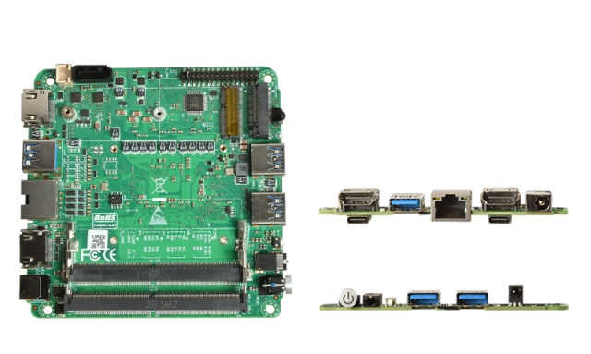

Product Specifications
Processor system | Onboard Intel Alder Lake-U/-P series processor
Processor system | EFI BIOS
Memory | 2* DDR 5 SO-DIMM , total maximum 64 GB
storage | 1 *M.2 M-Key 2280 (NVMe PCIe 3.0 x4/SATA3.0 protocol)
storage | 1 * SATA 3.0 interface , 2Pin 5V power supply
show | 2* HDMI 2.0 interface , support 4096 x 2160@60H z
show | 2*Type-C interface , support DP 7680 x 4320 @60H z and USB3.2 Gen2
Board edge I/O interface | Power button, 2-in-1 audio jack, reset button, 2*USB3.2 Gen2
Board edge I/O interface | DC JACK, 2*HDMI, 2*Type-C, 1*LAN
Board edge I/O interface | Single and dual network optional: single network, 1*USB3.2 on the rear I/O; dual network, 1*USB3.2 on the rear I/O
Expansion interface/function | External TPM2.0 is optional, not available by default. The default is CPU built-in TPM2.0
Expansion interface/function | 1 * M.2 E-Key ( PCIe+USB2.0 protocol, WIFI/BT module)
Expansion interface/function | 1*RS232 pin header, spacing 2.0mm
Expansion interface/function | 1*USB2.0 pin header, 2x5Pin, spacing 2.0mm
Expansion interface/function | 1*4Pin PWM CPU FAN
power supply | DC 12-19 V, 120W or more
Work Environment | Working temperature: -20℃ ~ +60℃; working humidity: 5% ~ 90%
Work Environment | Storage temperature: -40℃ ~ +85℃; Storage humidity: 5% ~ 90%
Operating System | Windows 10, Windows 11, Linux
size | 1 00 x1 00 mm
net weight | Without radiator, about 120 g ; with radiator, about 220 g
AD600CA (R100)

产品尺寸 单位：mm

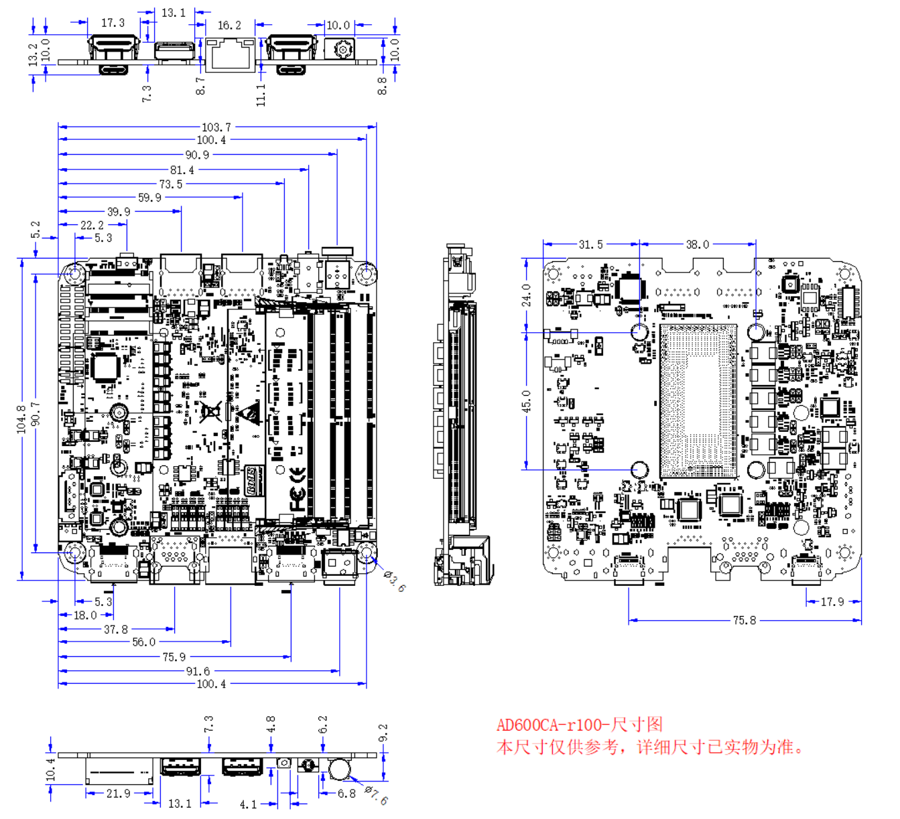

Ordering Information
model | Optional items | Option Description
AD600CA | Onboard Intel Alder Lake-U/-P series processor | I3-1215U/I5-1235U/I7-1255U  I3-1220P/I5-1240P/I7-1260P
AD600CA | TPM2.0 | External TPM2.0 optional
AD600CA | Single and double network optional | Single and double network optional

