
AD30NA6L (R100)

Features
- Onboard Intel Alder Lake-N series processor;
- 1 x DDR5 SO-DIMM, total maximum 16GB;
- 6 x Intel i226-V (4 x Intel i226-V optional);
- 1 x M.2 2280 SSD, E-Key, B-Key;
- 1 x HDMI2.0, TPM2.0;
- DC 12-19V; Size: 120 x 120mm.
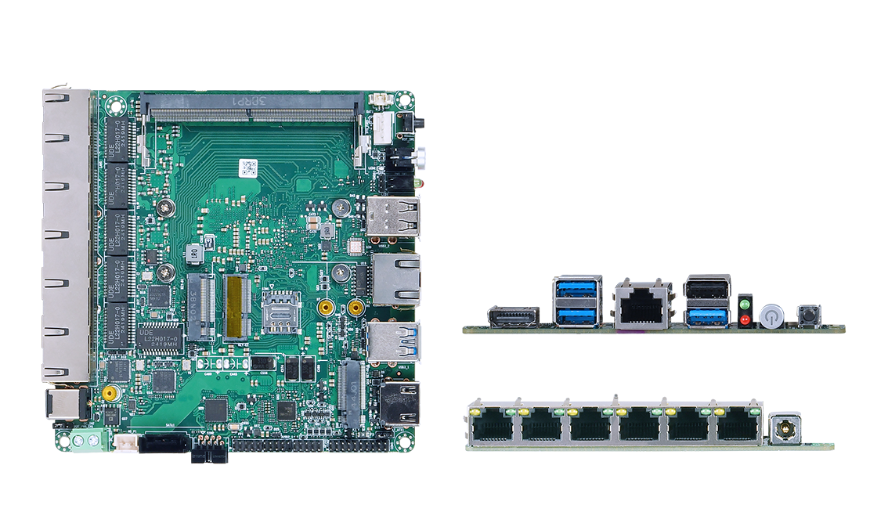

Product Specifications
Processor system | Onboard Intel Alder Lake-N series processor, TDP 15W
Processor system | EFI BIOS
Memory | 1 x DDR5 SO-DIMM, total maximum 16GB
Storage | 1 x M.2 M-Key 2280 (SATA3.0 protocol)
Storage | 1 x SATA3.0, 2Pin 5V power supply
Display | 1 x HDMI2.0, support 4K@60Hz
Board edge I/O interface | Power button, reset button, 3 x USB3.0, 1 x USB2.0
Board edge I/O interface | DC JACK, 1 x HDMI, 1 x Console
Board edge I/O interface | 6 x Intel i226-V (4 x Intel i226-V optional; POE optional for LAN1/2/3/4, POE has a pop-up switch)
Expansion interface/function | External TPM2.0 optional, not available by default. The default is CPU built-in TPM2.0
Expansion interface/function | 1 x M.2 E-Key (PCIe+USB2.0 protocol, WIFI/BT module; no PCIe protocol when using 4LAN)
Expansion interface/function | 1 x M.2 B -Key (USB3.0+USB2.0 protocol, 4G/5G module)
Expansion interface/function | 2 x RS232 pin headers, pitch 2.0mm; 8-bit GPIO, 2x5Pin, pitch 2.0mm
Expansion interface/function | 1 x USB2.0 pin header, 2x5Pin, pitch 2.0mm; F _Panel
Expansion interface/function | 1 x 4Pin PWM CPU FAN, 1 x 4Pin PWM SYS FAN
Power supply | DC 12-19V, 60W or above
Work environment | Working temperature: -20℃ ~ +60℃; working humidity: 5% ~ 90%
Work environment | Storage temperature: -40℃ ~ +85℃; Storage humidity: 5% ~ 90%
Operating system | Windows 10, Windows 11, Linux
Size | 120 x 120 mm
Net weight | Without radiator, about 130g; with radiator, about 250g

AD30NA6L(R100)

Measurement Unit: mm

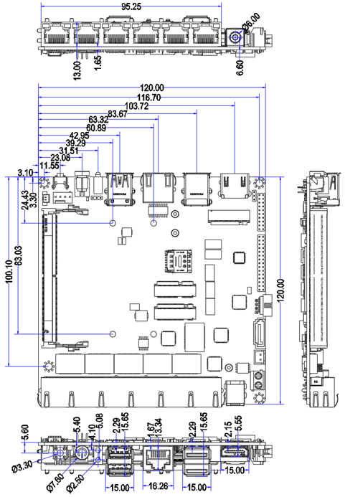

Ordering Information
Model | Optional items | Description
AD30NA6L​​ | Onboard Intel Alder Lake-N series processor | N100/N305 etc.​​
AD30NA6L​​ | network | 6Lan or 4Lan for option
AD30NA6L​​ | POE optional | POE optional for LAN1/2/3/4
AD30NA6L​​ | TPM2.0 | External TPM2.0 optional

